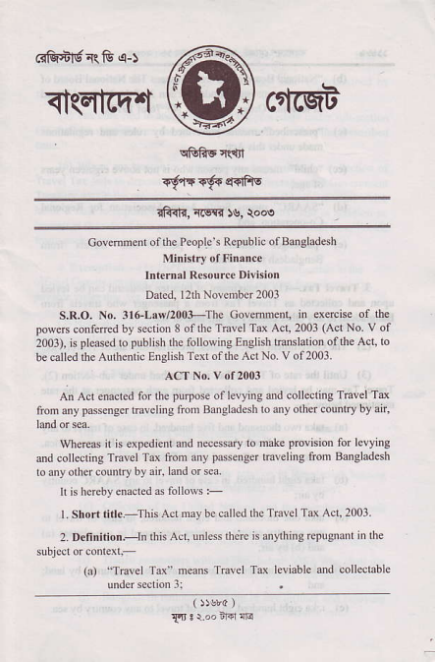
ffi ^{6iffi-RG,s-)}
<t(El-cq.t
r9{$6erdfls
Golemnenl oflbe Peple\ Repnblic ofBmeladesh
Minisrry of Fin.nce
lnrernal R6ource Division
Dated, I 2lh Novembcr 2003
S.R.O. No. 3r6-L!8/2003-The Covement, in exercise of the powes conlered by scclion 8 oflhe Tdvel Td Acl, 2003 (Act No. v of _{2003), is} pldsed lo publish $e following Enelish Feslarion ofthe Acl,lo be called tho Authentic English Tcxt ofthe ActNo. v of2003.
ACT No. v of 2001
Ar Ad enacted for lhc purpose of levyine and couedins Travel Ta _{6on any} psseng€r tFveling lron Banglodesh b any olhft conntry by ar,
WteEs it is expedicnl and necessary to malc provision for levying fld collecting _{Tnvel Tax fton any} passen8er haveling from Baheladesh lo any orhcr country by an hnd or sea.
lr is hereby enacted.s folloss :-
l. Short titl.-This Act may be called lhe Tr.vel Tax Acl,200l. 2. Dednition,-ln lhis Act, unless lhe;e is anything rePuSlanl in $e
_{(al} ^{'"Travel} Td'ncans Travel Td levia6le and colleclable undcrsection3;
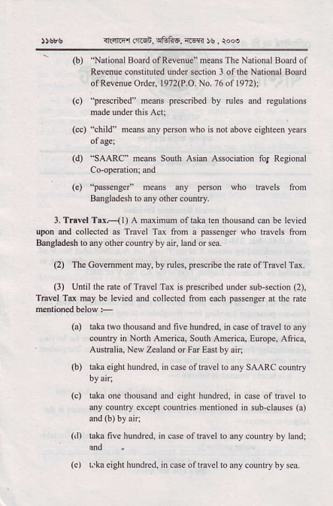
_{,rsb} q...|rFrar@n qFEF. ^{lffi} !s. rooe
' (b)'NaliomlBoardofRevenle'neansTheNarionalB@rdot Revenue constituled under strtion 3 of the National Bcrd
of Re\endeOrder, 1972(P.O. \o. /6of o72r;
(c) pE$ibcd' ne&s prqcibol by oles dd recllarions rodeund.rdisAd:
(c0 tniu" meahs aiy psson who is not above eighreen yea6
(d) SAARC' fteans South Asian Associalio. fol R€gioml Co-opeEtionj md
_{(e)} ^{'bssdcE} medns .ny penon who rraveh ftom hngl.desh to my olher counFy.
3, TFrcl T.<l) A mdimum of lal. len thousmd ce be lwied lpon ed colleted as Tmvel Td tom a passene€r who lavels fron Bdeladcsh to my olhcr counlry by air, land or sca
(2) TlECovmmen'mry.byruh..pacdberhe6reof lrdelTd.
₀₎ Until the Eft ofTmvel Td is prescribed mder sub-seclion (?), T6vel Ta nay be l€vied fld colLcled fron erch passenger d tne nle
(a) rata two rhouend and nve hunded, in case oftBvel to my country in Norlh America, South Afteric4 Euiope, Alrica,
' Alstralia. New Zealand or Fa. €asl by ani
(b) I.ka eieltt hundred, in case o{ lsvel lo any SAARC counlry
_{G)} taka one $ousnd dd eieht hundEd, in cas. of lravel to a.y counfy excepl couna'cs nenrioned ^{in sub-clauses} G)
and(b)byoir;
(li l3l€ five hundred, in cse of tavel to my counrry by landj {nd
ler rtieighr huid(d, rncseof navel loanycolnrrvb) seo.
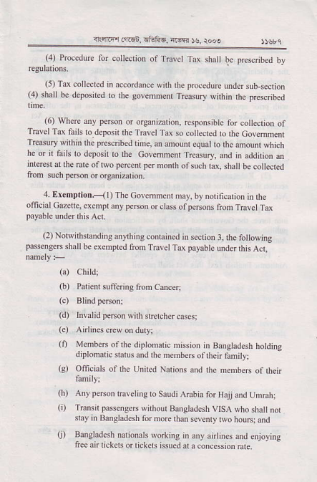
{r _{.r-r .L6n} qi6nE, ^{;(w} )s, rooa
(4) ProceduE for collection of Travet Tu shalt be ^{prescribed} by regulations,
(5) Td collecred in accordance with rhe procedur undo slb-secrion (4) shall be deposl€d to ^{lhe} sovernmenl Treasury withi. ^{the} Drescribe.t
(6i WheE my pfton or oigajation, esponsible fo. collcction of Travel Td faih to.deposit ihe Tdvel Tu so coltectcd to lbe Covemhent TFas!ry ^{*nhin the} _{Fescnbed} tine, an mouor equat ro the amout whi€b he or it fails to delosn b lb. covelmenr Tredury dd in addilion e
int res! at $e rats of lwo percent pe! nonth of such t4 sha be colleded liom such penoh or orga.iution.
4. Erenplion.< I ) Tbe Colennent may. by nolificalron n he otrcial C@e!te, exempt dy p€rson or class of pesoff from T,avel Td
(2) Notwirhsranding an,lhins contained _{in secrion} ^{j,} the foltowing passengs shall be exenpred tlm TBvet Td paFbte udd this Acr,
(a) Cbild;
_{O)} Patimt suf€ri.g from Cmc6j
(d) Invalid peno. with srrcrchft cases;
(e) Anuns dew on duty;
(0 Membe6 ofthc diplonaric nissjon in Baogtadesh hotdin8 diplomatic srarus md rhe nemben of fien fmityj
(g) Ofiiciah ofthe United N ions and the nenrbe ofmctr
(h) Any person rraleling to Saudi Alabia for Hajj lnd Un6h; (i) Tiaisn psscnges wirhout Baogladesh VrSA whoshallnot slay in Bansladesh for ooE lbah selenty lwo ho!s; and
(j) BrFeladAh _{na. or,ls ro} ^{jng} In lnj a ines ard el,oyrng ftee air tickeh or tickets issuedai aconcession nre
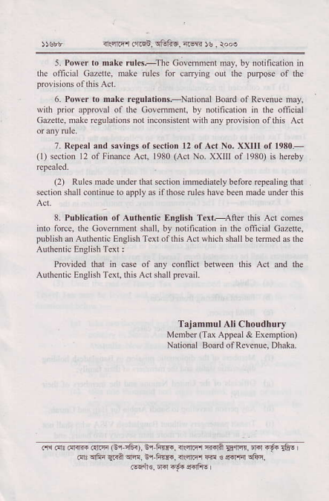
arri.ir.'rcn, lriifis, ^{lriw} )s, rooe
5. Poscr lo nak€ rul*,:The Covednenl may. by notificarion i. lhe official C6zclrc, nate rulcs for canying out the puqose of the
6. Power ro n,ke reguhrions--Nalional Bodd ol Revenue nay, vilh prior approval of the Govennenl. by notincadon ih lhe official Cderle, oake regulurionsot inconsislent wnh any provision oflhis Act
?. R€pe.l.nd savings orFciion 12 orAct No. XXIII of 1980.- (l) section l2 of Fimnce Acl, 1980 (Acl No. XXIII oI 1980) is hereby
(2) Rnles mde Dnderhat secrio. iFnediately before iepealing rhat s(tion shall conlinue lo opplyas ifthose rules have been nadc undd this
8. Pnblic,tion or Aurheniic English Text,--Anr this Acr comes into force. thc Cov€mm€d snall by notitcation in lhe oiicial Cazetle, publishdAudenticEnghhTextofrhisAcrNhichshallbeleme
Provided thal i. case of any cornid between lnis Acl dd the Authenlic Enslish Text, this Act shall pEvail.
Tajlnnul Af Cnoudnury
Menber (Td Appeal &Exenption)
National B@rd ofRevenue. Dhaka.
.* .{ri ffi .tEF Gr iFi), tr hir{. rRird nln _{!g{Jn,} rrd -.6 €-. _{m} ^{qfra} EFA w, ir-tur., ireftc1 w € e_{E{ !6n.
Fq,lr€- Ifd {6. rrrfto I

